**Year 2 Semester 1 (2025)**

IT2120 - Probability and Statistics Lab Sheet 07

Before starting the lab sheet, you need to create a folder in your desktop and save all your working inside the folder. Set the working directory to that folder using the following command:

setwd("paste the path of the folder")

**Eg:-** setwd("D:\\2025 - Sem 2\\IT2120\\Lab Sessions\\Lab 07") Use R to find the probabilities in the following questions.

1. A bus arrives at a bus stop uniformly between 7:00 a.m. and 7:30 a.m. Let the random variable X represent the number of minutes waiting for the bus between 7:00 a.m. and 7:30 a.m.



**FacultyofComputing**

* + - 1. What is the probability that the bus arrives within the first 10 minutes after 7:00 a.m.?

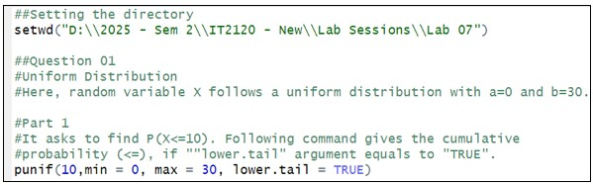

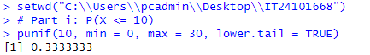

* + - 1. What is the probability that the bus arrives after 7:20 a.m.?

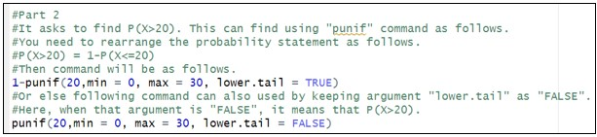





1. The time (in hours) required to repair a machine is an exponentially distributed random variable with parameter.
   * 1. Find the probability that a repair time takes at most 3 hours.

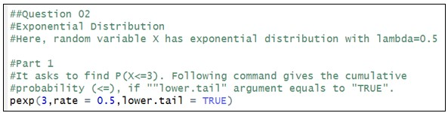



* + 1. Find the probability that a repair time exceeds 4 hours.

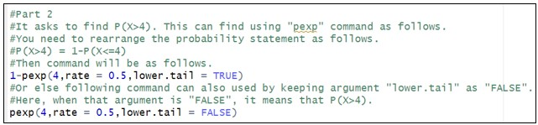

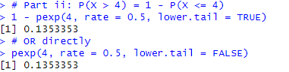

* + 1. Find the probability that a repair time takes between 2 to 4 hours.

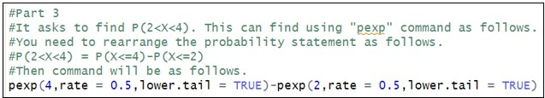



1. Assume that human body temperatures are normally distributed with a mean of

36*.*8C◦ and a standard deviation of 0*.*4C◦

* 1. A hospital uses 37*.*9C◦ as the lowest temperature considered to be a fever. What is the probability that randomly selected person would have a fever?

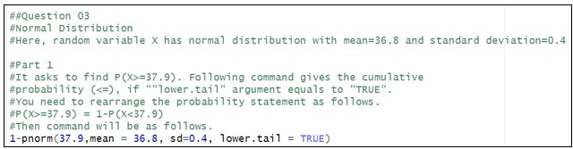

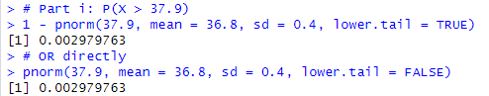

* 1. What is the probability that a randomly selected person would have a temperature between 36*.*4C◦ and 36*.*9C◦ ?

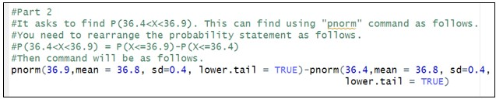



* 1. Physicians want to decide the maximum temperature which is needed for further medical tests. What should be that temperature, if they want only 1.2% of the people to fall below it?

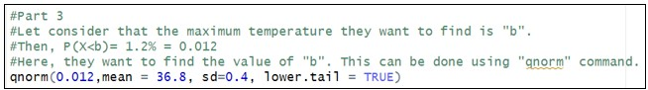



* 1. Physicians want to decide the minimum temperature which is needed for further medical tests. What should be that temperature, if they want only 1.0% of the people to fall above it?

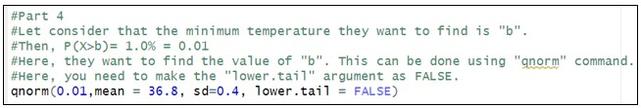



# Exercise

**Instructions**: Create a folder in your desktop with your registration number (Eg: “IT.......”). You need to save the R script file and take screenshots of the command prompt with answers and save it in a word document inside the folder. Save both R script file and word document with your registration number (Eg: “IT........”). After you finish the exercise, zip the folder and upload the zip file to the submission link.

1. A train arrives at a station uniformly between 8:00 a.m. and 8:40 a.m. Let the random variable X represent the number of minutes the train arrives after 8:00 a.m. What is the probability that the train arrives between 8:10 a.m. and 8:25 a.m.?



1. The time (in hours) to complete a software update is exponentially distributed with rate. Find the probability that an update will take at most 2 hours.



1. Suppose IQ scores are normally distributed with a mean of 100 and a standard deviation of 15.
   1. What is the probability that a randomly selected person has an IQ above 130?



* 1. What IQ score represents the 95th percentile?

